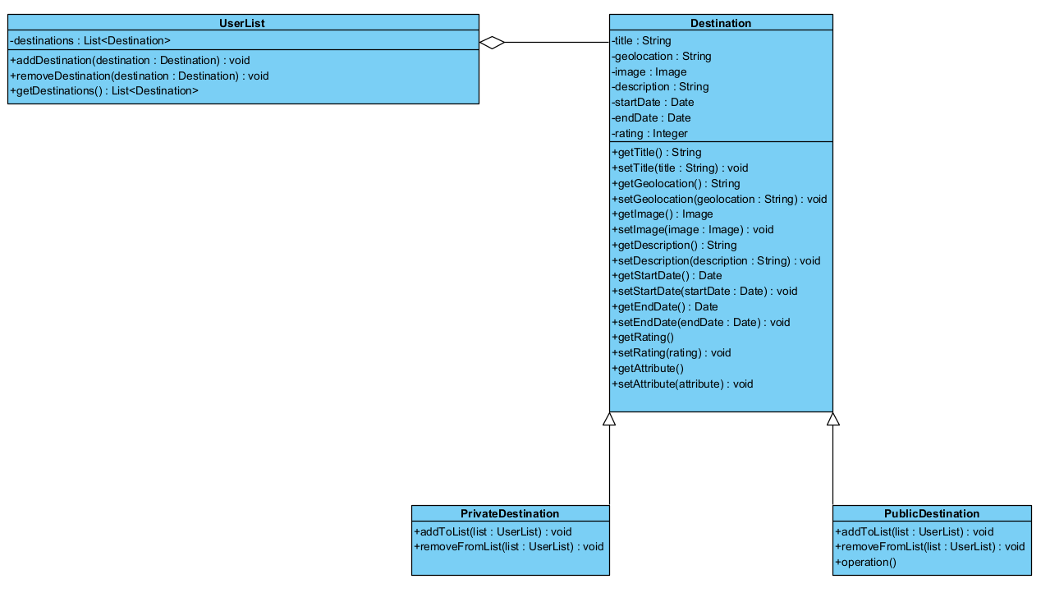

context UserList

inv destination:

self.destinations->size() >= 1 and self.destinations->size() <= 100

context Destination

inv stayDates:

self.startDate < self.endDate and self.rating >= 1 and self.rating <= 5 and self.endDate – self.endDate > 1 and self.endDate – self.endDate < 30

context UserList::addDestination(destination: Destination)

pre:

not self.destinations->includes(destination) and self.destinations->forAll(d: Destination | Tuple{d.startDate, d.endDate} <> {destination.startDate, destination.endDate}) and ((destination.oclIsKindOf(PrivateDestination) and destination.userlists->forAll(ul: UserList | not ul.contains(destination))) or destination.oclIsKindOf(PublicDestination))

context UserList::addDestination(destination: Destination)

post:

self.destinations->size() = self.destinations@pre->size() + 1 and

self.destinations->include(destination)

context UserList::removeDestination(destination: Destination)

pre:

self.destinations->includes(destination)

context UserList::removeDestination(destination: Destination)

post:

not self.destinations->includes(destination) and self.destinations->size() = self.destinations@pre->size() – 1